***HR KPIs***

* **ABSENTEEISM RATE**

Evaluate the engagement of your employees.

This HR metrics measures the average absenteeism rate as a percentage of the total working days among all employees. It is a highly important HR KPI as it illustrates the employee’s motivation and engagement in his work and more generally in the company. Studies have shown in the past that workers with a low motivation and engagement are much more likely to call in sick or skip some days of work. It is important to watch this metric over time and to reduce it, because it will inevitably impact your business: be it the company atmosphere or the overall productivity, in the end your finances and the general well-being of the business will be at risk.

Performance Indicators:

If your find your absenteeism rate of the past month(s) higher than the historical rate, investigate and find the reasons: is it specific to one department or a company-wide issue? Why? Then implement appropriate measures to remediate the situation.

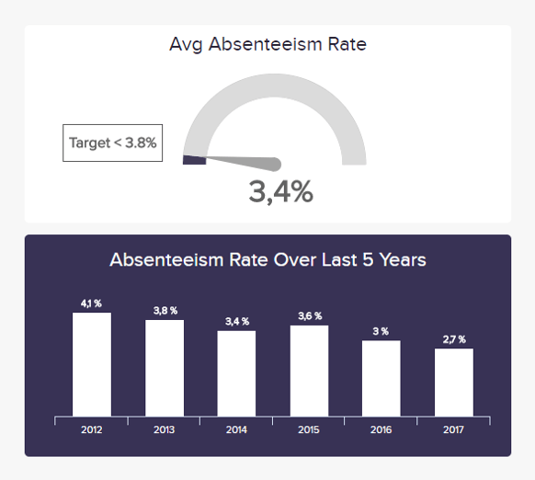

* **OVERTIME HOURS**

Monitor your employees' workload in detail.

Overtime hours are a great indicator on many levels, but have to be interpreted differently depending on the context. A sudden rise in overtime hours might translate a temporary higher volume of orders, or an economic growth. They can show the dedication of employees as well as flaws in work processes, or maybe an understaffed workforce that has to deal with a high pressure. This will directly impact another of the HR metrics we have seen previously: the absenteeism rate. Indeed, if people do not mind working overtime every now and then, an amount of overtime hours that goes through the roof and a permanent high workload will decrease both motivation and employees’ satisfaction, which maybe will result in an absenteeism rate increasing.

Performance Indicators

The reasons for a permanent high overtime should be investigated, as it also can confine the potential growth of a company when it results in missing orders or projects.

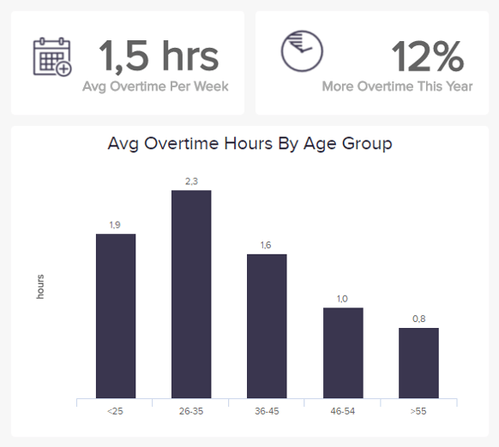

* **TRAININGS COSTS**

The best investment is in your employees.

Here is a Human Resources KPI example used when you want to measure how much you have invested onboarding new hires and upgrading one’s education. It is a helpful metric to track employees’ development costs, and make smarter decisions when it comes to developing their skills set after they have been hired. However, training costs should not be limited to new hires – more and more workers today wish they had a better job development and wish for a continuous learning in their position. Investing in an employee for him/her to develop his/her already acquired skills, or new ones, is an option often too little considered by HR management. Often enough, the return on training costs is greater than the initial investment.

Performance Indicators

Implementing a little knowledge test and evaluating the scores of employees can help you see if the training provided was effective.

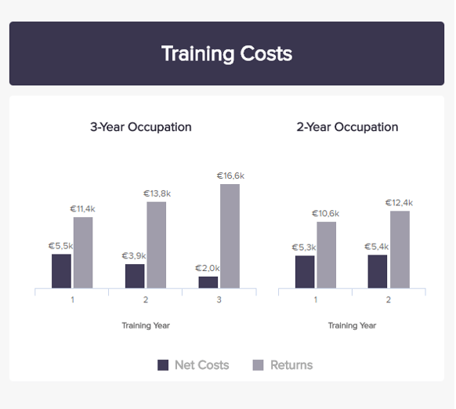

* **EMPLOYEE PRODUCTIVITY**

Measure the overall effectiveness of your workforce.

The Overall Labor Effectiveness is a very interesting and complete HR KPI, that takes several dimensions into accounts when measured thoroughly. It is usually calculated by dividing the total sales by the number of employees. But for a deeper analysis, it is good to consider the components that have effect on the productive output: the availability, ie. the amount of time where employees are actually working; the performance, or the amount of product delivered; and finally the quality, or the number of perfect / saleable products produced during that time. It is more of a manufacturing-oriented approach that can nonetheless be applied to other sectors. Beyond reviewing employees’ performance, productivity measurements can help them understand how much they have done and how well they did it, and adjust their ways of working when needed.

Performance Indicators

The higher this ratio, the better it is for the company. Measuring productivity accurately can ensure greater profit but also increased employee motivation and recognition.

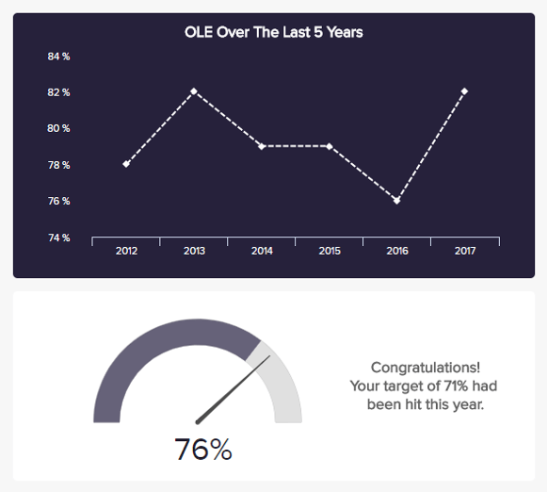

* **COST PER HIRE**

Evaluate what it takes to find the perfect fit.

Here we have a pretty straightforward HR KPI, that measures the amount of resources you invest for each new employee you need. It covers all the costs from recruiting (advertisement / marketing, referral incentives, time cost of recruiter reviewing and selecting CVs, then conducting interviews) to training (time cost of manager / instructor, materials, and time cost of a new employee). These costs pile up rather quickly and heavily on a company’s budget, this is why hiring shouldn’t be taken lightly – but without employees, work cannot be done and business cannot be run. And this is in the end, the bottom line of every business: investing in talents that will bring even more value back. So even if the investment might make the finance department frown, the potential of talent acquisition is always worth it.

Performance Indicators

Measure the cost per hire according to the recruitment source, and see which is the most or least expensive. This shouldn’t be a unique reason to decide whether the source is a good one or not, as the turnover rate (how long people stay in the company) is important, too.

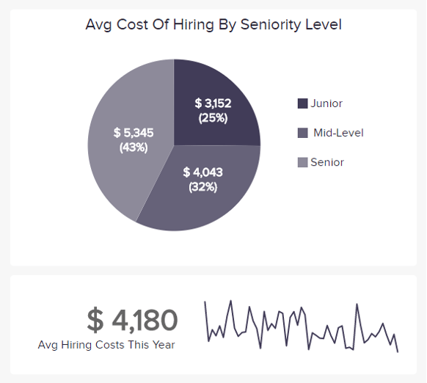

* **TIME TO FILL**

Monitor how long you need to find a new employee.

Another easily understandable HR performance metric as the definition lies in its name. This metric simply measures the time elapsed between the moment a job offer has been posted and the moment a new employee has been hired for that specific position. Just like the Recruiting Conversion Rate, it tracks how efficient the hiring process is in terms of time resources spent to fill a vacancy. It also informs to do realistic business planning, as lay-off or someone quitting has to be handled and anticipated when possible. A low figure is always better; however, it shouldn’t be the main criteria. Investing time is important to find the best fit and a good hire might cost in the beginning but the benefits will always better greater afterwards.

Performance Indicators

To work this metric right, keep in mind that it is a process evaluation more than an objective to reach by lowering the numbers at all costs. The objective of recruitment remains the outcome, ie. an employee fitting the position well.

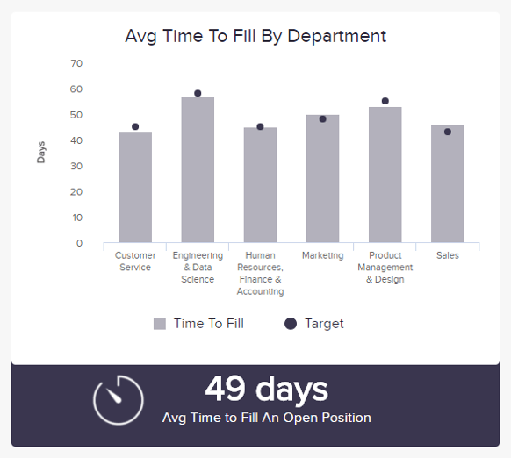

* **TURNOVER RATE**

See how your retention efforts work.

In Human Resources, employee turnover measures how many of your employees leave, voluntarily or not. It indicates the success of your company in terms of retention efforts, and just like the time to fill, is a good help to plan for talent replacement. Preferably, people who do not fit in the company leave – and it is not a bad thing for both parties. However, when your talents leave, turnover becomes a problem, because turnover is final: people never come back, or very seldom. And usually, people quit their managers, not their job. This is why you should track the root causes if you have a high turnover rate and identify potentially problematic areas that need to be fixed.

Performance Indicators

A low turnover rate is always better for a satisfactory performance in the long run and lower recruitment costs in total.

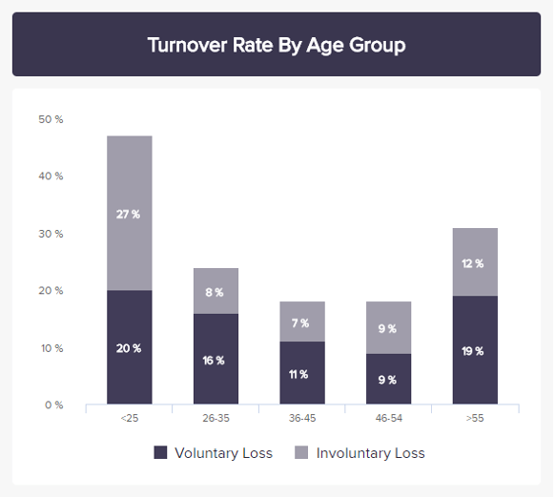

* **FEMALE TO MALE RATIO**

Measure the gender diversity in your company.

This HR metric is not often used and remains a bit of a taboo in many companies. Measuring the ratio of female to male workers, especially in top-management positions, can tell a lot about a company. Some industries are very gender-biased (IT and engineering are overcrowded with men, while caring and nursing tend to be in majority female). This has a historical and societal explanation, but as our societies evolve it is important to be aware about and encourage diversity – be it gender diversity, but also nationality-wise and curriculum-wise. The more horizons you gather, the broader the view and the more diverse the approaches and innovation possibilities you will have. That is an incredible competitive asset in our globalized economies.

Performance Indicators

There is no target rate in particular as it also depends on the availability of the candidates at a certain time. But countless studies prove that a balanced environment – especially in boards of direction – are much more successful than any other in the long run.

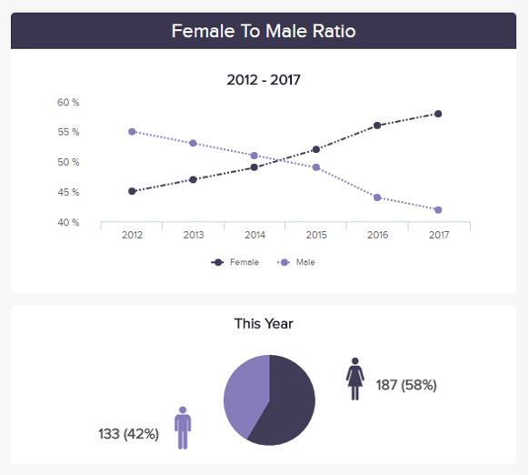

* **AVERAGE TIME STAY**

See how long your employees stay in your company.

The last of our Human Resources KPI example is good indicator on the attrition of your company, and lets you know if you are good at retaining talent. This HR metric tracks the average number of weeks, months or years an employee stays within a company. It is efficient to measure both retention and employee satisfaction with his position, his team and/or managers. You already know how much hiring and training a new employee costs – so the longest the time he or she stays, the better! That way, you can earn greater return on your investments. This metric is even more powerful if measured alongside other KPIs like the Employee Turnover: a short time stay combined with a high turnover does not announce anything good and the reasons for that should be assessed as soon as possible.

Performance Indicators

The longer, the better for your company’s return on hiring and training investments.

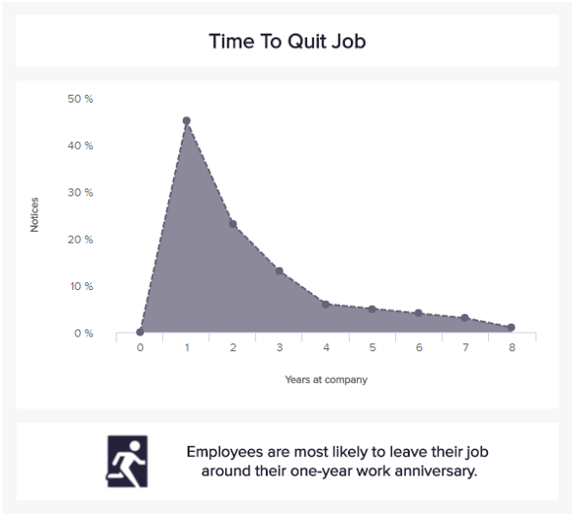

* **PART-TIME EMPLOYEES**

Watch the evolution of part-time workers over time.

Part-time employees work fewer hours in a day or a week than full-time ones, who are usually employed around 40 hours per week. There are several advantages to have part-time workers, especially when you start your company and cannot take too much risk, or when a position is needed but does not require someone to dedicate 40 full hours on it. Many different people can look for part-time jobs as these are fitting better their needs and schedules. But CEOs should keep in mind that cumulating several part-time employees to avoid the benefits and costs a full-time position would require is poor strategic choice, as part-time workers may take longer to learn the job, the company culture, and can hardly be retained if they want a full-time job that never materializes.

Performance Indicators

Track the evolution of part-time contracts over time and parallelize it with other metrics like company performance and results, or employee satisfaction and engagement.

